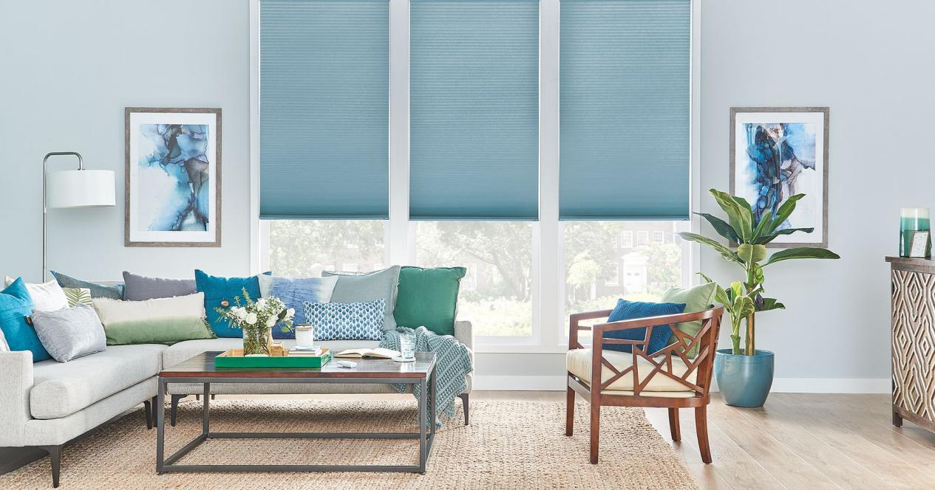

$987

Designed to look like real wood, Bali Composite and Faux Wood Blinds offer timeless beauty on a budget. Besides being affordable and resistant to humidity, faux wood and composite blinds can add distinctive character to any room—light colors add cheerful charm to a kitchen or living room, while dark colors create a thoughtful atmosphere for a study or den.